“It doesn’t beat the real thing”:
Educational experiences of students with ASD during COVID 19

EIS Action Research Grant 2020-2021

Louise Shambrook
Don MacKeen
City of Glasgow College

June 2021

ABSTRACT

This qualitative study examines what students with an autistic spectrum disorder (ASD) on Transitions, a specialist Further Education course in Scotland feel about their course. It further considers how they have coped with the educational constraints during the COVID-19 pandemic.

The research was conducted using questionnaires and semi-structured interviews over the course of one academic term. Asperger syndrome, an ASD, is briefly explained along with the challenges and opportunities of this social difference for students and teachers. The structure of the Transitions course is outlined.

Four themes emerged from the research. Firstly, the students experienced difficulty with their education prior to coming on the Transitions course, often due to the nature of their ASD, often experiencing bullying, struggling to fit in and be like the majority of students. Secondly, the students were self aware and viewed themselves as different which caused feelings of anxiety and a lack of confidence. Thirdly, the students aspired to achieving and moving on to other college courses, but often lacked direction as to what they would study. And finally, online learning had an impact as they struggled with new technology, working from home and problems with motivation, although some students appreciated being able to be in their own space and learning new technology. The research found that the students preferred face to face teaching. Students struggled to complete work and stay on task and lecturers were not able to build up the relationships of trust that are necessary in order to provide suitable guidance.

This research provides important points for teachers to consider when working with ASD students, particularly as distance learning may become the “new normal” in the short term. An actually inclusive educational system will need to grapple with the realities that ASD students, their teachers and families face regarding distance learning. It is recommended that educational institutions provide sufficient ASD specific training, user friendly technical support and tailored individual online learning. The researchers recommend further study into online learning and ASD.

INTRODUCTION

This qualitative research investigates the opinions, feelings and experiences of young people with Autistic Spectrum Disorders (ASD) attending a specialized Further Education college course called the Transitions Course. This course is based in Scotland.

Intentions and Rationale

We are Transitions Course Lecturers and have both recently completed independent research focusing upon the design and nature of the Transitions course.

MacKeen (2019, 2017) examined the effect of a knowledge-based curriculum (Geo-capabilities) on a specialized course and Shambrook (2019) investigated how the students feel about education and what aspects of education they find beneficial. We both concluded that more in-depth research was essential, especially on how to improve the learning and teaching of students with a diagnosis of ASD.

The impact of COVID-19 to teaching and learning for our students is also considered.

Context

The Transitions Course has been running for 23 years at City of Glasgow College. It was designed to deliver education and guidance concerning the transition from school to further education or work to young people (aged 16 -19) with a diagnosis of ASD. The main purpose of the Transitions course is to provide an educational setting where the young people can develop their own strategies to cope with real life situations.

Scope

The objective of this research is to widen the knowledge of the needs of young people with ASD in further education. The study involved qualitative research using questionnaires and semi-structured interviews to elicit the views of students with ASD. The study was carried out over one academic term.

Background: The Policy Context and Review of the Literature

What is ASD?
Autism Spectrum Disorders (ASD) are a wide variety of social/communication disorders (Wing, 1997). The Transitions course is designed for the particular ASD diagnosis of Asperger syndrome (AS), a term coined by Lorna Wing (1981) in order to aid parents and practitioners in understanding that there are people who display “autistic features” while being able to “speak grammatically” and desiring social interaction.

How does ASD affect individuals – Triad of Impairments
The key feature of ASD is the “triad of impairments” (Wing & Gould 1979). These are difficulties (or differences) in three areas:

- Social interaction: the individual is often anxious in social situations and can behave in an odd or eccentric way. They may become withdrawn. Often their behaviour appears to be rude.

- Communication: conversations may be one-sided monologues about the individual’s area(s) of interest.

- Imagination: the individual struggles to shift their focus and may engage in repetitive behaviours.

Many people on the spectrum report online communication as “less tiring” and more “safe”, possibly due to the issues created by the Triad of Impairments and the experience of being what Goffman referred to as a “faulty interactant”: those “who make themselves and others uneasy in encounters” (Ryan & Räisänen 2009).

Further Education and ASD

It is estimated that there are “93,400 children and young people in the United Kingdom” with a diagnosis of AS (Humphrey & Lewis 2008) so there is a strong likelihood that teachers in the UK have worked with students with AS.

People with AS think analytically (Bryson 2005) and often do not recognise social hierarchy (Sainsbury 2009). On the one hand students with AS may excel in certain detail-oriented subjects yet may struggle with the social demands of the classroom.

For many young people with AS, the transition from school to further education presents difficulties and challenges. Powell (2002) suggests the education system for students with AS does not cope with their learning styles and this then contributes to a lack of access and completion of college courses. In addition, a high proportion of young people with AS feel un-prepared for the changes that occur in further education (White et al 2016).

Changes such as:
- Being treated like an adult and having more responsibility for their own learning.
- Making their own decisions.
- More independence and lack of supervision outside classes.

These maybe positive defining changes for some students but they can lead to barriers for students with AS if pre-access preparation for the change, and specialised support is not put into place (Breakey 2006).

Developing a sense of community, or feeling accepted by other students in the classroom is known to have positive benefits. Such as reducing the number of students that drop out the course (Tinto, 1993) and increasing the level of support and cooperation for one another (Bruffee, 1993; Dede, 1996; Wellman, 1999). Rovai (2002) suggests the concept of this sense of community can be applied to a virtual learning environment.

Inclusion Debate and Policies

In Scotland, inclusion is embedded in the Curriculum for Excellence (CfE) and “mainstreaming” is government policy. A former HMiE head asserted that while “inclusion is not easy...it’s not optional” (Pirie, Head & Brna 2005).

At first glance this is laudatory, however in practice inclusion is often a case of “managing” students who need support (Armstrong, Armstrong & Spandagou 2011). Students with ASD can be placed in settings that are often inappropriate (Lindsay, Proulx, Scott et al 2014). It is part of the Scottish Strategy for Autism (2018) that people on the spectrum should have “choice and control” and “independence” while also becoming “active citizens” who can “successfully [transition] from school into meaningful educational or employment opportunities”.

It is EIS policy to support the “mainstreaming” of ASN students, but they note that there has been an increase in ASN students while at the same time a decrease in ASN teachers and support staff (EIS 2019). Ferriday (2019) has shown that while staff are willing to work with ASN students, they lack training and resources, and this has led to a lack of confidence in their abilities to deliver for this group of students.

Geocapabilities

The GeoCapabilities approach of Lambert, Solem & Tani (2015) seeks to use geography to deliver a knowledge-based curriculum rooted in the values of social justice. The aim is to provide students with knowledge which can empower them.

The teaching of Geography on the Transitions course developed from work with students using urban gardening (MacKeen 2019). Urban gardening has opened up discussions around the nature of citizenship and the rights of individuals to create the places they live in. Geography has now become a vehicle for the values of the Transitions course’s “hidden curriculum”.

COVID Impact on Education in general

COVID-19 has created challenges for schools, students and parents/guardians (Sharp, Nelson, Lucas, Julius, McCrone & Sims 2020). Educational institutions were forced to shut and classes moved to online learning environments in a matter of weeks, which did not allow for the sort of preparation that would be needed to provide a dynamic educational experience. Students were often unable to access digital equipment or infrastructure, or if they did it was often insufficient, exposing a digital divide (Halliday 2020). Schools and colleges rushed to prepare online lessons of variable quality. In Scotland, a scandal ensued when it was revealed that student work had been assessed by the Scottish Qualifications Authority based on prior work in particular post codes, meaning working class students were disadvantaged (McEnany 2020).

COVID Impact on ASD students (online learning)

Students with ASD were impacted as students in general were, in terms of difficulties accessing digital equipment and difficulties adjusting to an online learning environment. However, for these students there were additional challenges. Many students on the spectrum rely on specialist provision for their communication and social difficulties (Stenhoff, Pennington & Tapp 2020). Isolation, changes in routine and difficulties in adapting the home space for learning were serious challenges for young people and their parents/carers (Latzer, Leitner & Karnieli-Miller 2021).

Parents and carers of young people with ASD were concerned that they were missing out on specialist education (Latzer, Leitner & Karnieli-Miller 2021). Parents/carers noted the return of obsessive behaviours and the loss of social skills. However, some reported this period as being “positive and even beneficial”, due to parents/carers who were able to maintain a positive outlook and accommodate children’s interests. These parents/carers were able to cope best with the situation (Latzer, Leitner & Karnieli-Miller 2021).

There are also “hidden inequalities and injustices” (Pellicano & Stears 2020), as people on the spectrum lose structured environments that help to maintain their mental health and, in some cases, face domestic abuse (Aman & Pearson 2020).

Necessity of this research

While attention has been given to the educational challenges and needs of young people with ASD, more research is needed into the particular educational approaches that allow this group of students to be successful.

This unique situation of a pandemic presents unforeseen issues and benefits for us all. Research is essential to widen the knowledge of the effects of these changes, especially in education.
RESEARCH DESIGN

Methodology

We decided to use an interpretative research design. The interpretivist paradigm views the world as open to interpretation, as opposed to seeing the world as understandable with data and statistics (Denscombe 2014). To use this type of research, there needs to be an element of trust between the researcher and the participants (Bhattacherjee 2012). The participating students have interacted and developed some rapport with their lecturers and the lecturer/student relationship has been established. It is inevitable that power struggles between teacher and student also need to be addressed (Bernstein 1974) when conducting the research. However, trust and rapport with students with AS could decrease stress levels for the student which could lead to more open discussions.

The interpretivist researcher also needs to recognise their own “social background, likes and dislikes, preferences and predilections, political affiliations, class, gender and ethnicity”. (Thomas 2013:109). Maintaining a passive attitude when questioning could prevent these factors having an influence on the findings (Denscombe 2014).

Procedures of Research

Ethical Considerations

Ethics need to be fundamental to good research (Denscombe 2014). The Ethical Guidelines for Educational Research (British Educational Research Association 2011) suggest these factors of best ethical practice:

- Informed consent

- Transparency

- The right to withdraw from the research

- Attention to any harm arising from participation taking part in research

- Anonymity of participants

Our approach to ethical considerations with young people with additional needs is influenced by our professional roles as Lecturers. We have ongoing communication with our students and have developed working relationships with them. Cameron and Murphy (2007) deem this factor as critical for gaining consent for research.

We also had to ensure students understood the nature and rationale of our research. To do this we distributed an information sheet (Appendix A) to explain the nature of the research. The students were given the opportunity to ask further questions and discuss further with a parent or a guardian. A consent form (Appendix B) was then emailed to participating students.

Ethics approval was obtained via the City of Glasgow College Ethics Committee and all GDPR protocols were observed.

Participants

The following criteria was used for selection of the participants:

- Had a diagnosis of Asperger’s syndrome

- Are currently enrolled on the Transitions Course at the City of Glasgow College

- Able to comprehend a research project and able to give consent

- Consent that the information they gave would be anonymous and recorded

Recruitment

Participants were recruited for the research from the whole of the Transitions Course. There are 40 students on the full time Transitions course which comprises of 4 groups.

The participating students’ ages ranged from 16 to 19. 11 students completed the first online questionnaire and 7 completed the second questionnaire (see Appendix C). 12 students agreed to participate with individual online interviews via Zoom. Delays and repeated emails and communication led to organising and reorganising the interviews.

Questionnaires

There were two questionnaires distributed to the students. The first, in December 2020 was used as a tool to gain general opinions about the Transitions course. The same questionnaire was distributed again in March/April 2021 to investigate if opinions were changing or remaining the same. This questionnaire did not receive as many responses as the first questionnaire.

The questionnaire needs to be straight forward and easy to understand (Denscombe 2014). The students had previously used Google Forms in an online situation as this software proved to be easy to use. In order to maintain validity, the participant’s identity remained anonymous. Completed questionnaires (Appendix C).

Semi-structured interviews

The use of semi-structured interviews for researching experiences of people with ASD is popular (Krogh and Lindsay, 1999). This method of interviewing combines the structure of questions and a freedom to ask further questions if they arise. This factor is particularly important for our students because further elaboration is sometimes necessary for the student and interviewer to understand. In addition, people with a diagnosis of ASD may need a longer time to process the question and provide an answer (Cridland, Caputi and Magee, 2015). The interviewers need to be empathetic, realise it is ok to have silences, not rush and to remain non-judgemental throughout (Thomas,2013). The questions are open-ended and do not hint towards any bias (Charmaz, 2006). There were five interview questions (see Appendix D).

The interviews took place in the learner’s and researcher’s homes via Zoom. The students were interviewed at an agreed scheduled time and recorded. These recordings were transcribed (see Appendix E) and the participants remain anonymous. Face –to-face interviews were regarded most appropriate for the research questions rather than telephone or email because of the reasons already mentioned.

Data Analysis

The data was analysed using Braun and Clarke’s thematic analysis (2006). This involves collecting all the data together and developing Themes. This analysis method can be regarded as not having to rely on a theory to underpin ideas. The Themes develop when analysing the interview transcripts and questionnaire results. This method is similar to grounded theory but differs in that is independent of theory and epistemology.
FINDINGS AND ANALYSIS

The data obtained for this research consists of interviews with 11 students with a diagnosis of ASD currently attending the Transitions Course. It also includes data obtained from a questionnaire (see Appendix 2) distributed twice (in December 2020 and April 2021).
This research has evolved and developed and has inevitably incorporated the impact of COVID-19 and distance learning on the participants. These findings will have an impact upon learning and teaching young people with a diagnosis of ASD on the Transitions Course and further afield. These are the results of the data analysis.

Themes
The questionnaires and interviews were analysed and a summary of the themes that emerged follows.
Table 1. Summary of the Themes

Theme | Description
Difficulties for students with ASD in education | Students wanting to “fit-in” with other students and become “normalish”  Some students couldn’t keep up with other students academically  Some students treated differently by other students and teachers  Some students were bullied
How the students view themselves | Unconfident  Having low academic skills  Different  Anxious  Stressed  Difficulty communicating  Over-thinkers
Aspirations | Not sure about career  Want to apply to more college courses
Advantages/disadvantages of online learning | Not as engaging as face-to-face classes  Problems with technology  Distractions at home  Lack of motivation  Difficulties scheduling  Need more help  Don’t need to go outside home  More flexible – can do when it suits you  Learn new technology

Difficulties for students with ASD in Education
A high proportion of students interviewed experienced problems or barriers to learning at school. Issues such as feeling like they want to fit in with the rest of the students, feeling different in a negative sense and being bullied were expressed openly.
Participant 7 describes feelings of socially isolated at school:
School was quite, eh… it wasn’t really easy. You know, it was hard for me to, like, fit in with most of the kids, you know.. I was often, like, sort of on my own, because I was seen as, like, a really weird kid, no one wanted to, like, hang out with me and all that.

The desire to be similar to other students and not to feel different was repeated by a number of interviewed students. These findings agree with other research (Holliday Willey, 1999; Carrington and Graham, 2001; Humphrey and Lewis, 2008; Bos et al; 2003; Goffman, 1968). Participant 2 describes this:
… primary school was really kind of difficult for me, not because of what they were doing but because of how I reacted to things back then. I always thought I was different from everyone else, in a way, and obviously I was because I was the only person… because I went to a mainstream primary school. So, I was, like, one of the, like, the two autistic people in there.

The issue of young people with a diagnosis of ASD being bullied at school surfaced in the interviews. These findings resonate with other research by Wainscot et al (2008) and Humprey and Symes (2010) as well as MacKeen (2020) and Shambrook (2019).

Participant 4:
…school life is just a mixed rollercoaster for me, because my primary school was one of the best times I have ever had school. And, em, in my secondary school, it was a bit downhill, but I think I got through it…..I just got bullied, and some teachers just didn't bother to report it.

Young people with a diagnosis of ASD continue to experience difficulties in education despite developments in inclusion policies. School pupils with differences in behaviour or social skills are often viewed as ‘odd’ or ‘strange’ by their peer-group, which can result in them being easy prey for bullies (Humphrey and Lewis 2008). Lack of reporting of bullying incidents, or not understanding different forms of bullying also leads to further problems (Reid and Batten, 2006).

Stigmatisation and bullying have been shown to result in high anxiety and school-phobia, especially for a young person with ASD (Hebron & Humphrey, 2014).

How the students view themselves

Many students are positive about having Asperger’s and some do not feel different from other neuro-typical people. Most do however and for some this is a matter of upset. Their low levels of self-esteem were noticeable. As were their difficulties communicating with others and feelings of anxiety and stress.

Some students perceive having a diagnosis AS as beneficial in that it enables them to focus on areas that interest them.

Aspirations

The findings show the majority of the students were vague about their future college course choice and did not really have any concrete ideas or plans. They hoped the Transitions course would equip them with specific course ideas.

Participant 7
Before I came to college I didn't know what I wanted to do. I had no clear plan. With the Transitions course, I really want to, eh, help me find something I’m really interested in, hopefully I can take that on.

Education and career aspirations for young people have been affected by the disruption of the pandemic (Princes Trust, 2020). Outcomes for people with Asperger syndrome are poor, particularly in relation to abilities, therefore it is vitally important that these young people receive specialist education and training (Lorenz & Heinitz 2014).

Advantages/disadvantages of Online Learning

The unique situation of having tuition and classes online presented both problems and benefits for the students.

Problems

Not as engaging as face-to-face classes

The questionnaires and interviews show that the majority of the students thought that face to face teaching would help them most on the Transitions course:

December 2020 Questionnaire
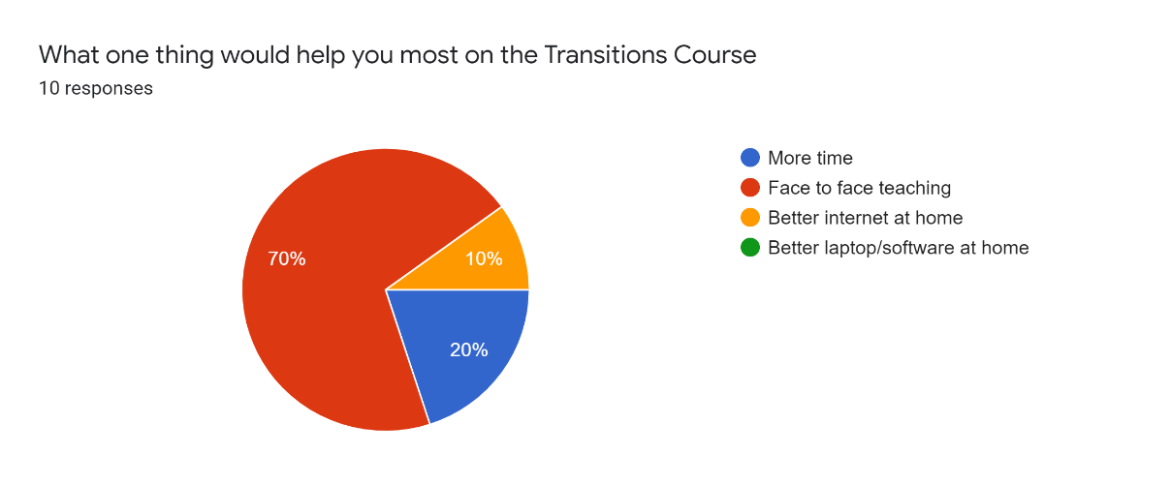
April 2021 Questionnaire
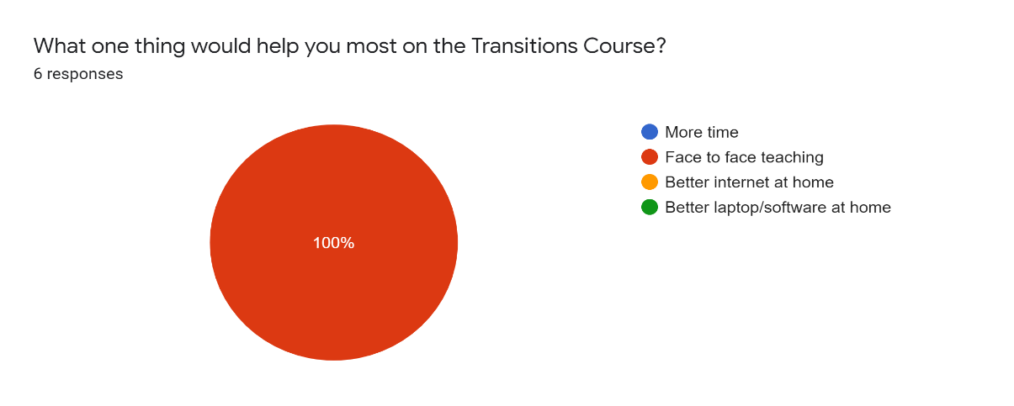
The students did not find the online classes as engaging as being in a class with a lecturer and other students.

Participant 8:
It’s okay. It gets the job done, but, I mean, it doesn't beat the real thing. I’d much rather be in a classroom with other people and the teachers and that.…

Participant 5:
…sometimes it’s… if it’s stuff you can’t show and it’s really difficult, that’s when I struggle with it.

These findings and other research (Stenhoff, Pennington & Tapp 2020) illustrate the complications people with AS encounter when face to face teaching is not available.

One of the most important aspects of the Transitions course is the relationship between the lecturer and the students. By building up relationships of trust with the students, the lecturers are able eventually to challenge the students and to push them to develop in terms of their behaviour, their relationships with others and their academic work. In 2020-21, the students and lecturers had to deal with an entirely new situation of building trust. There was partial college-based learning that was staggered - with half of a group attending at a time. This was disruptive to the flow of learning and to the building up of relationships with the students. By not having face to face teaching on a regular basis, any problems or anxieties the students had could be concealed. People with AS often present a front and don’t disclose they are experiencing difficulties (Ryan & Räisänen 2009). This has been apparent when students do not fully understand college work yet give the impression they do. It is difficult for a student with AS to initiate dialogue (Ryan & Räisänen 2009), and this difficulty is amplified in an online situation.

Teaching approaches which would be used in face to face learning situations were harder to employ in online classes. A lecturer would normally use visual feedback from observing student responses and reactions to gauge how a lesson was being understood or enjoyed. In the online situation students were given the choice to leave on cameras or switch them off, with most selecting the latter option. This meant that a normal feedback source was not available.

Another important aspect of the Transitions course is the relationship the students have with their peer group. Establishing a sense of belonging and a feeling of “fitting in” with others because of their common diagnosis has been shown to have a positive effect on the Transitions Course (Shambrook, 2019). This element of the course has decreased. Online learning restricts the social aspect of the course and many students felt they had “missed out” in this area.

Problems with technology

The technical aspect of teaching online has created difficulties for some of the students.

Participant 1:
… despite me being millennial, or whatever, I can’t stand doing the work on technology...I just find it impossible to concentrate and… it’s, like, harder to, like, organise in my brain for some reason...writing stuff down is easier somehow.

The problems of unreliable internet connections, inability to connect to Zoom meetings and not having access to laptops and software were cited. These problems caused stress and frustration for the students.

Distractions at home/Difficulties scheduling/lack of motivation

Being at home and not in college presented a unique set of problems for the students:

Participant 7:
… obviously when you’re in college, you are in the college to learn and there’s nothing else that can distract you. But when I’m at home, I have this kind of thought process that, yeah, I need to do this work, but there’s a lot of other things in my home that I’d rather do. But when we’re at college, obviously there’s nothing else around you, it’s just focusing on the work and it’s a lot easier to focus. So, yeah, I much prefer actually physically going into the college and doing it.

The levels of online college work produced outside the Zoom classes was lower in comparison with work produced inside college. Difficulties focusing and sustaining attention on subjects not familiar or “interesting” are traits associated with AS. Scheduling a routine to complete work at home was also problematic. The distinction between a study space and a relaxing space is less clear when working from home (Stenhoff, Pennington & Tapp 2020).

The lecturers found there was a temptation for the students to do something other than independent learning when at home. There were no serious consequences for failure to complete work, as it was decided that added pressure should not be put on students in already stressful times. This meant that students did not feel any urgency about completing classwork, and many chose not to attempt or finish set work.

Transferring the course to online teaching has resulted in some noticeable difficulties:

- not looking at the Intranet at all outside classes,
- spending days deliberating whether they are doing the work correctly,
- only concentrating on one subject and neglecting the rest of their subjects,
- not turning up to classes.

Benefits
When considering how the students have coped with the academic year it appears that many reported finding positives from it. However, it is important to remember that they tend to be forgiving towards people they trust, as well as downplaying their own feelings (Shambrook 2019).

Can stay at home

A minority of the students have clearly benefited from being able to work at their own pace in their own environment. Many of the students reflect on being more comfortable in their home environment. This factor could make the students more open to learning new things. The social anxiety of being in the classroom with others can create a barrier to learning (Morrissette, 2021). In the future lecturers may need to consider that some of the academic work may be completed more effectively when students are working at home. There is also the possibility that delivering a certain number of classes online could be helpful in terms of student engagement, in particular for those for whom physical attendance at college has proved to be too stressful or problematic in other ways.

It remains to be seen if students returning next session have as many difficulties interacting with each other as they have in the online setting.

College work is more flexible, can do it when it suits you

Several of the students found benefits with having the flexibility to complete college work outside online class hours.

Participant 9:
I like the online learning because you can be casual about it.

Doing college work outside the conventional hours of college (9am – 4 pm) appeals to some students.

Learn and use new technology

With an increased reliance on technology, most students have learnt and developed I.T. skills.

Participant 12
Well, you had to learn new tech ways to try and work with digital stuff. Like computers and that, you can learn new techniques and that.
Participant 8
I’ve got a lot more use out my laptop.

In the experience of the researchers in the past Transitions students have generally struggled with technology. Perhaps the necessity of needing to use the technology to engage with the lessons has been a positive one, and we will need to consider how we can encourage this when students are back in the classroom.

Geography

MacKeen (2019, 2017) has proposed using geography as a teaching tool for students with AS because it “provides the students with a way to ‘map’ their place, to test ideas, to debate, to discuss. As geography has clear boundaries, it opens the way to abstract discussions.” Although the geography classes were limited in scope due to online teaching, there were some positive developments.

Overall, students showed good geographical knowledge and recall. Knowledge of human geography was particularly good, as were map skills.

Participant 11
Well, I’ve learned quite a lot about human environments, eh, mostly about economically, like, what makes a country economically viable. And different development factors as well. I also, things about glaciers and rivers and how it forms the landscape.

Unfortunately, due to the limitation of online teaching and learning, student's progress was diminished, and therefore, it is difficult to draw detailed conclusions.

CONCLUSION

This research confirms that young people with ASD experience challenges in formal education because of their differences. These challenges or barriers result in the young person having feelings of exclusion, low self-esteem and anxiety. The Transitions course attempts to provide an environment for learning more suited to their needs.

The findings suggest that the Transitions course does not transfer well to an online setting. The most noticeable observation was that all of the students perceived having face to face contact would improve their learning.

While the students displayed good geographical knowledge, the GeoCapabilities approach employed suffered from the lack of in-person class time. Further research will be needed post-pandemic to determine its value.

The students also did not have the same learning in a group experience that they would have had in college. Evidence of the positive impact of feeling part of a group in education is well documented (Bruffee, 1993; Dede, 1996; Wellman, 1999). Shambrook (2019) observed the sense of “fitting in” and belonging in the group were a perceived benefit for most of the students attending the Transitions Course.

To be able to transfer these positive aspects of learning in a group to a virtual classroom is more difficult for students with social communication differences.

Recommendations

- Ensure training/awareness of the needs of ASD students

- Educational establishments to have reliable, easy to use online technical facilities and software available for all learners.

- Include some online individual learning in addition to classroom learning

The researchers believe that this study shows the need for further research, particularly around ASN teaching and the use of virtual learning environments. This could be done in conjunction with practitioners from mainstream education.

REFERENCES

Aman, M.G & Pearson, D.A (2020) Challenges for Child and Adolescent Psychiatric Research in the Era of COVID-19 Journal of Child and Adolescent Psychopharmacology Vol. 30, No. 5

Armstrong, D., Armstrong, A. C., & Spandagou, I. (2011). Inclusion: by choice or by chance? International Journal of Inclusive Education, 15(1), 29–39. https://doi.org/10.1080/13603116.2010.496192
Bernstein, B. (1974) Sociology and the sociology of education: a brief account. J.Rex, (ed.). London: Routledge and Kegan Paul.

Bhattacherjee, A. (2012) Social Science Research: Principles, Methods, and Practices. Scholar Commons. Retrieved from:
http://scholarcommons.usf.edu/oa_textbooks/3.

Bos A.E.R., Pryor J.B., Reeder G.D. & Stutterheim S.E. (2013) Stigma: Advances in Theory and Research, Basic and Applied Social Psychology, 35:1, 1-9, DOI: 10.1080/01973533.2012.746147

Braun, V. and Clarke, V. (2006) Using thematic analysis in psychology. Qualitative Research in Psychology, 3:2: p.77–101.

Breakey, C. (2006) The Autistic Spectrum and Further Education. Jessica Kingsley Publishers. London and Philadelphia

British Educational Research Association (2011) Ethical Guidelines for Educational Research. ISBN: 978-0-94667-32-8

Bruﬀee, K. A. (1993). Collaborative learning: Higher education, interdependence, and the authority of knowledge. Baltimore: John Hopkins University Press.

Bryson, S. E. (2005). The autistic mind. In M.L. Bauman & T. L. Kemper (Eds.), The Neurobiology of Autism (2nd ed., pp.34-42). Baltimore: The Johns Hopkins University Press
Cameron, L. and Murphy, J. (2007) Obtaining consent to participate in research: The issues involved in including people with a range of learning and communication disabilities. British Journal of Learning Disabilities, 35 (2): 113–120.

Carrington, S. and Graham, L. (2001) Perceptions of school by two teenage boys with Asperger syndrome and their mothers: a qualitative study. Autism, 5(1): 37–48.

Charmaz, K. (2006) Constructing Grounded Theory: A Practical Guide through Qualitative Data Analysis. London: Sage

Cridland, E.K., Jones, S.C., Caputi, P., Magee, C.A., (2015) Qualitative research with families living with autism spectrum disorder: Recommendations for conducting semi-structured interviews. Journal of Intellectual and Developmental Disability. 40 (1). p.78-91

Dede, C. (1996). The evolution of distance education: Emerging technologies and distributed learning. American Journal of Distance Education, 10(2), p. 4-36.

Denscombe, M. (2014) The Good Research Guide (fourth edition). Maidenhead, UK: Open University Press. The McGraw Hill Companies

Educational Institute of Scotland (2019) Impact on teaching and learning: multiple children with ASN

Ferriday, G, (2019) An Exploration of the Factors that Impact Upon the Inclusion of Pupils with Additional Support Needs in Mainstream Secondary Education: The Staff’s Perspective. EIS Action Research Grant

Goffman Erving (1968) Stigma Notes on the Management of Spoiled Identity. Penguin Books.

Halliday, A. (2020) Digital Exclusion in Scotland Edinburgh: Inspiring Scotland

Holliday Willey, L. (1999) Pretending to be Normal. London and Philadelphia: Jessica Kingsley.

Hebron and Humphrey (2014) Exposure to bullying among students with autism spectrum conditions: A multi-informant analysis of risk and protective factors. Autism 2014, Vol. 18(6) 618–630

Humphrey, N., and S. Lewis. (2008). ‘Make me normal’: The views and experiences of pupils on the autistic spectrum in mainstream secondary schools. Autism: An International Journal of Research and Practice 12: 39–62.

Humphrey, N. & Symes, W. (2010) Perceptions of social support and experience of bullying among pupils with autistic spectrum disorders in mainstream secondary schools, European Journal of Special Needs Education, 25:1, 77-91, DOI: 10.1080/08856250903450855

Krogh, K. and Lindsay, P. (1999) Including people with disabilities in research: implications for the field of augmentative and alternative communication. Augmentative and Alternative Communication, 15: 222–233.

Lambert, D., Solem, M., & Tani, S. (2015). Achieving Human Potential Through Geography Education: A Capabilities Approach to Curriculum Making in Schools. Annals of the Association of American Geographers, 105(4), 723–735. https://doi.org/10.1080/00045608.2015.1022128
Latzer, Leitner & Karnieli-Miller (2021) Core Experiences of Parents with Autism during the COVID-19 Pandemic Lockdown. Autism 2021, 25(4) 1047

Lindsay, S., Proulx, M., Scott, H., & Thomson, N. (2014). Exploring teachers’ strategies for including children with autism spectrum disorder in mainstream classrooms. International Journal of Inclusive Education, 18(2), 101–122. https://doi.org/10.1080/13603116.2012.758320
Lorenz T, Heinitz K (2014) Asperger’s – Different, Not Less: Occupational Strengths and Job Interests of Individuals with Asperger’s Syndrome. PLoS ONE 9(6): e100358. doi:10.1371/journal.pone.010035

McEnany, J. (2020, 18 October) Revealed: Poorest Scots schools hit four times harder in SQA results scandal The National
https://www.thenational.scot/news/18802660.revealed-poorest-scots-schools-hit-four-times-harder-sqa-results-scandal/

MacKeen, D. (2017) Broadening Horizons: Using a GeoCapabilities approach to support students with a social difference (unpublished Master’s thesis) University College London, London
MacKeen, D. (2019) Geography for Students with a Social Difference Research in Geographic Education 21(1), 45-60

Morrissette M. (2021) School Closures and Social Anxiety During the COVID-19 Pandemic. Journal of the American Academy of Child and Adolescent Psychiatry 60(1): 6-7

Pellicano, E. & Stears, M. (2020) The Hidden Inequalities of COVID-19 Autism 24 (6): 1309-1310

Pirrie, A., Head, G., & Brna, P. (2005). Mainstreaming Pupils with Special Educational Needs: an evaluation. Retrieved from http://dera.ioe.ac.uk/5907/1/0021334.pdf
Powell, A. (2002) Title Taking responsibility : good practice guidelines for services - adults with Asperger syndrome. London: National Autistic Society.

The Princes Trust (2020). The Aspiration Gap Report. Censuswide. https://www.princes-trust.org.uk/about-the-trust/news-views/aspiration-gap-research Accessed 13/06/21

Reid,B and Batten,A (2006) “B is for Bullied: The experiences of children with autism and their families. The National Autistic Society http://www.autismtoolbox.co.uk/sites/default/files/resources/B_is_for_bullied

Rovai, A (2002) Building Sense of Community at Distance. International Review of Research in Open and Distance Learning 3 (1): 1-16

Ryan S. and Räisänen U. (2008) "It's like you are just a spectator in this thing": Experiencing social life the 'aspie' way, Emotion, Space and Society 1 (2): 135-143

Sainsbury, C. (2009) Martian in the playground: understanding the schoolchild with Asperger’s syndrome. Los Angeles: Sage.

Scottish Strategy for Autism (2018) COSLA/The Scottish Government

Shambrook, L (2019) “An investigation into how young people with a diagnosis of Asperger's syndrome experience a specialised further education college course” Birmingham University (Unpublished thesis)

Sharp, C., Nelson. J., Lucas. M., Julius, J., McCrone. T. and Sims, D. (2020). Schools’ responses to Covid-19: The challenges facing schools and pupils in September 2020. Slough: NFER.

Stenhoff,D.M, Pennington, R.C and Tapp, M.C (2020) Distance Education Support for Students With Autistic Spectrum Disorder and Complex Needs During COVID-19 and School Closures”. Rural Special Education Quarterly 39(4): 211–219 DOI: 10.1177/8756870520959658

Thomas, G. (2013) How to do your Research Project. 2nd ed. Sage: Los Angeles/London/New Delhi/Singapore/Washington DC

Tinto, V. (1993). Leaving college: Rethinking the causes and cures of student attrition. (2nd ed.) Chicago: University of Chicago Press.

Wainscot, J.J., P. Naylor, P. Sutcliffe, D. Tantam, and J. Williams. (2008) Relationships with peers and use of the school environment of mainstream secondary school pupils with Asperger syndrome (High-functioning autism): A case control study. International Journal of Psychology and Psychological Therapy 8: 25–38.

Wellman, B. (1999). The network community: An introduction to networks in the global village. In Wellman, B. (Ed.) Networks in the Global Village. p. 1-48. Boulder, CO: Westview Press

White, S.W., Elias, R., Salinas, C.E., Capriola,N., Conner, C.M.,Asselin, S.B., Miyazaki,Y.,, Mazefsky,C.A.,, Howlin, P.,, Getzel , E.E., (2016) Students with autism spectrum disorder in college: Results from a preliminary mixed methods needs analysis. Research in Developmental Disabilities, 56: 29–40.

Wing, L. (1981). Asperger’s syndrome: a clinical account. Psychological Medicine, 11(1), 115. https://doi.org/10.1017/s0033291700053332
Wing, L. (1997). The autistic spectrum. The Lancet, 350(9093), 1761–1766. https://doi.org/10.1016/S0140-6736(97)09218-0

Wing, L., & Gould, J. (1979). Severe impairments of social interaction and associated abnormalities in children: Epidemiology and classification. Journal of Autism and Developmental Disorders, 9(1), 11–29. https://doi.org/10.1007/bf01531288

APPENDICES
Appendix A Information Sheet
Appendix B Consent Form
Appendix C Questionnaires
Appendix D Interview Questions
Appendix E Example of Transcript

APPENDIX A
Information Sheet for Louise Shambrook and Don Mackeen’s Research

You will be given a copy of this information sheet.
Title of Project: Transitions Course Study 20/21
Name
Work Address: City of Glasgow college, 190 Cathedral St, Glasgow G1 2TG
Contact Details
Louise and Don would like to invite Transitions Course students to participate in this research project. It will involve filling out a questionnaire and being interviewed.
The main purpose of the research/study is to find out the what students with a diagnosis of Asperger’s syndrome think about being on a specialised college course.

Don or Louise will ask students questions about:
- Their move from school to college.
- How they feel about having a diagnosis of Asperger’s syndrome
- What they think about the Transitions course
- How they view their future
Things students should know about this research:
- The research is not part of the Transitions course.
- Students can withdraw at any time and do not have to give a reason why.
- Students do not give their names and no one will know that you took part in the study.
- The interviews will be recorded. The recording will be deleted after it is listened to.
- If you decide to take part, you will be given this information sheet to keep and be asked to sign a consent form.
- Completing a questionnaire means you wish to take part in the interviews later.
- Because you don’t need to write your name on the questionnaire it will not be possible for …….. to take out your answers once you have returned your questionnaire.
- If you have further questions about the questionnaires and interview, or you are not clear about the information or if you are uncertain about taking part, please speak to Louise, Don, Jacqui or Irene.
- Please discuss the information above with others if you wish
- It is up to you to decide whether to take part or not; choosing not to take part will not disadvantage you in any way.

All data will be collected and stored in accordance with the Data Protection Act 1998.
Thank you for reading this information sheet and for considering take part in this research.
APPENDIX B
Informed Consent Form

Please complete this form after you have read the Information Sheet and/or listened to an explanation about the research.
Title of Project: Transitions Course Study 20/21

Thank you for your interest in taking part in this research. Before you agree to take part, the person organising the research must explain the project to you.
If you have any questions about the research, please ask the researcher before you decide whether to join in. You will be given a copy of this Consent Form to keep and can check it at any time.
Participant’s Statement

Participant’s name:

- I confirm that I have read the notes written above and the Information Sheet, and understand what the study involves.
- I understand that taking part is voluntary and that I am free to withdraw from the research at any time, without having to give a reason.
- I confirm that I have had the opportunity to ask questions and the researcher has answered my questions
- Agree that my responses will not have my name on them and be anonymous.
- I understand that my responses will be recorded and I consent to use of this material as part of the project. No information that identifies me will be made publically available.
- I understand that the information I have submitted will be published as a report and I will have access to a copy.

- I agree to take part in this study.

Signed: Date:

APPENDIX C
Questionnaire
Google Forms: https://forms.gle/mD9YcnNXVEKzSwn96
1. Are you enjoying the Transitions Course?
Yes/No/Maybe
2. Which equipment at home do you have to do college work?
Computer/phone/other
3 Are you finding the course difficult?
Yes/No/Maybe
4. Are you finding the course too easy?
Yes/No/Maybe
5. Do you forget to do coursework?
Yes/No/Maybe
6 What is important to you about college?
Gaining knowledge
Finding out knowledge that is relevant to me
Learning things that will help me get a job
Socialising
Moving on to college courses

7. What one thing would help you on the Transitions Course?
More time
Face to face teaching
Better internet at home
Better laptop/software at home

APPENDIX C
Questionnaire 11 Responses (13.02.2021)
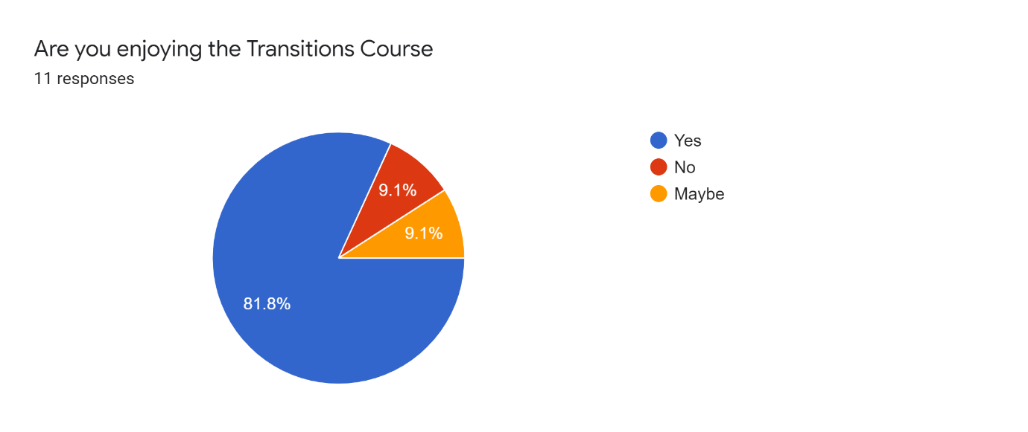
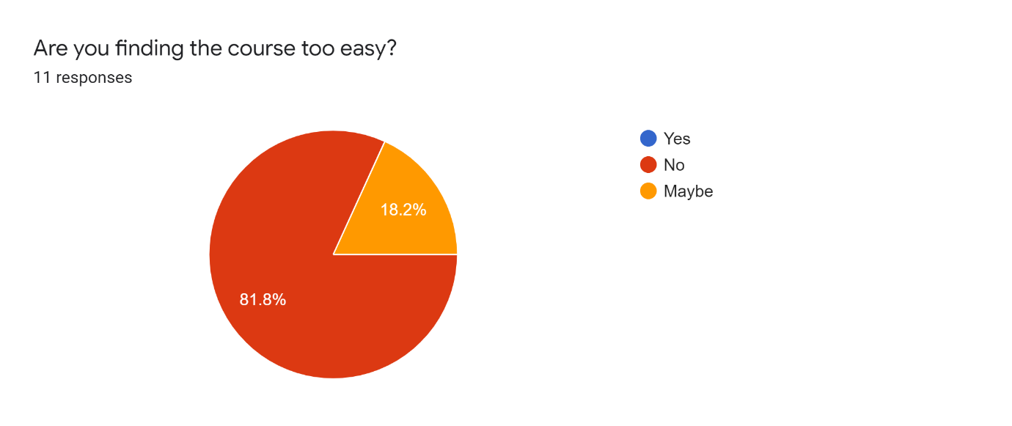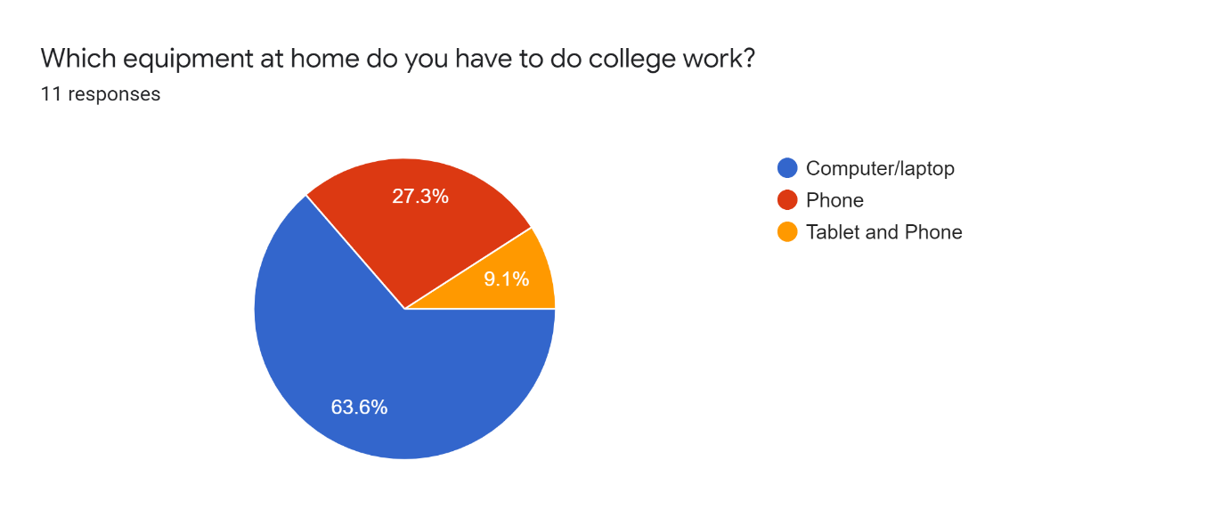
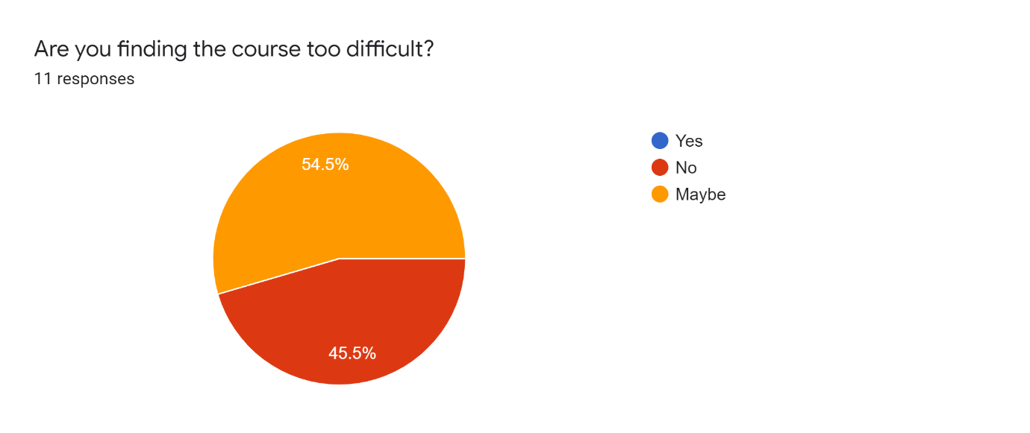
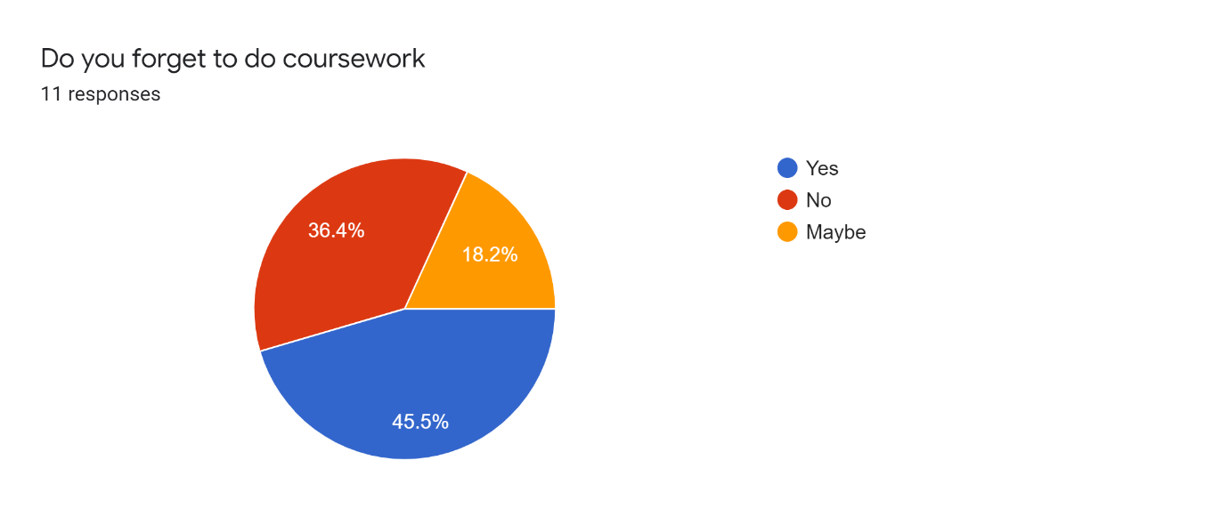
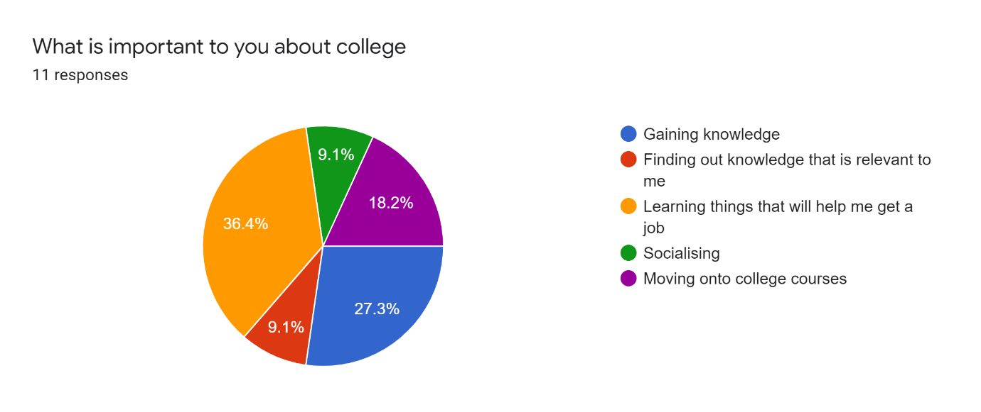
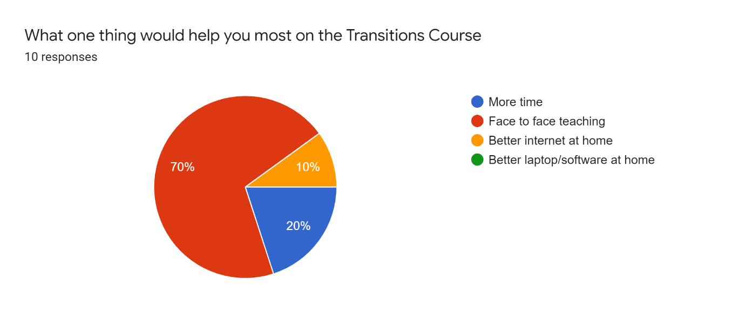

APPENDIX C
2nd Questionnaire (April 2021)

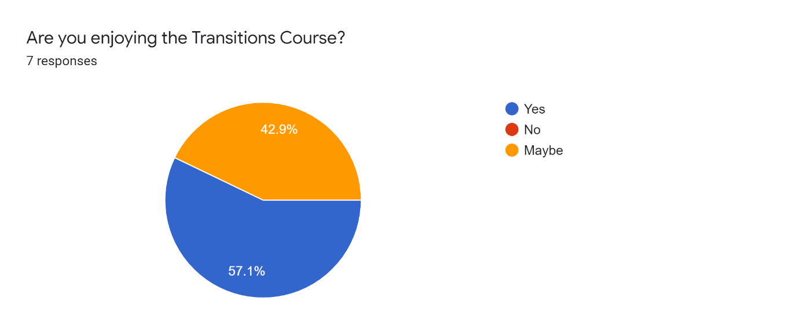
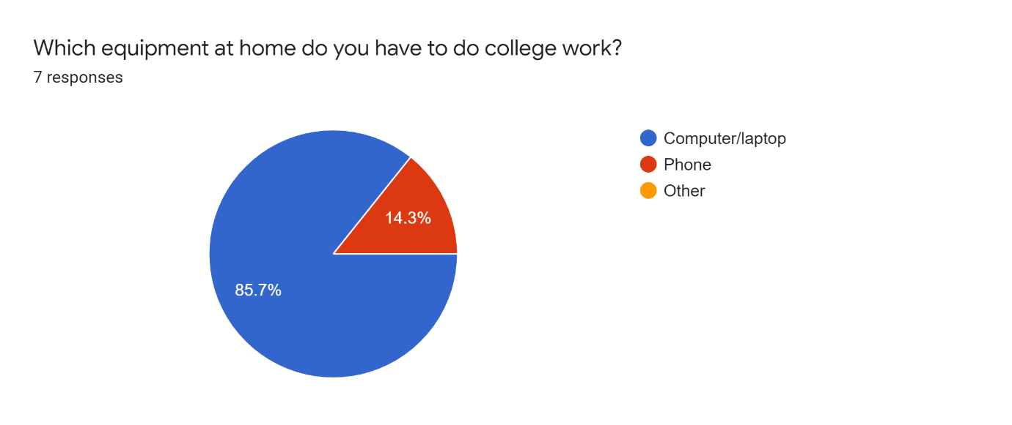
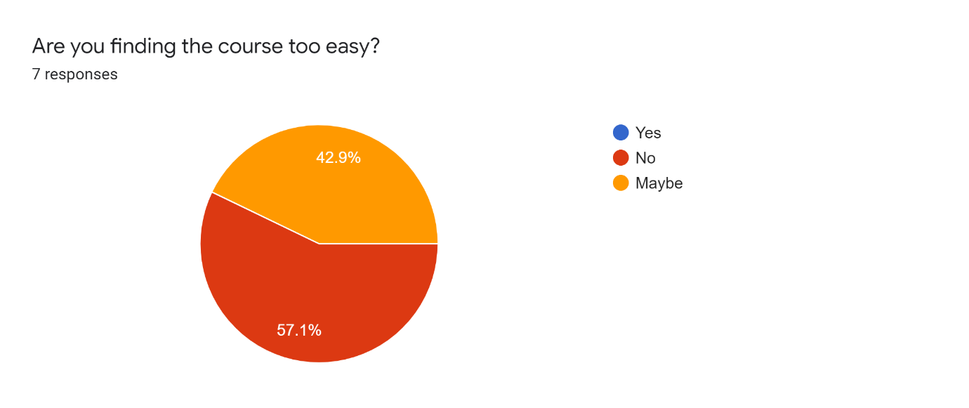
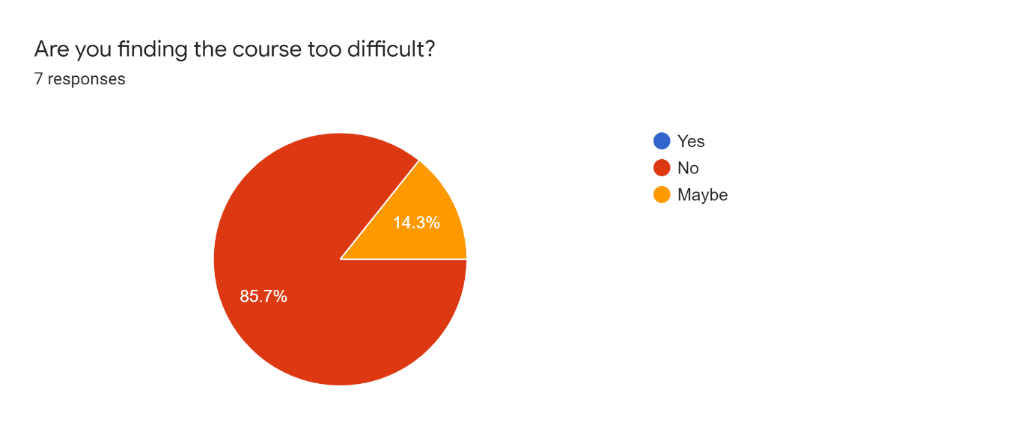
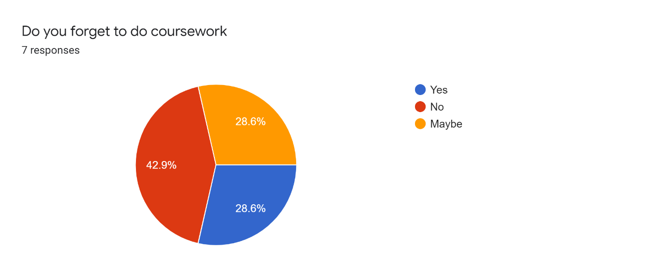

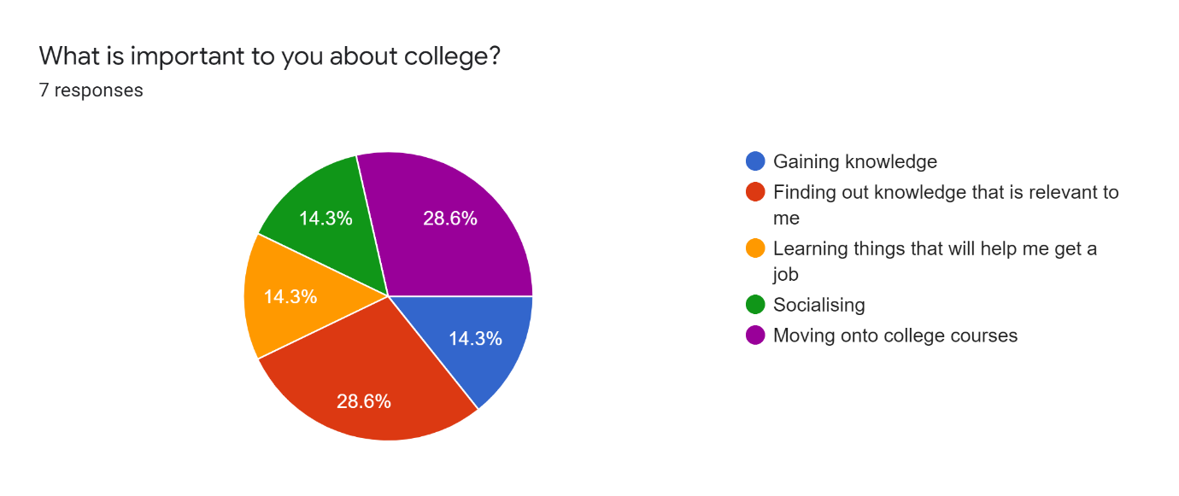
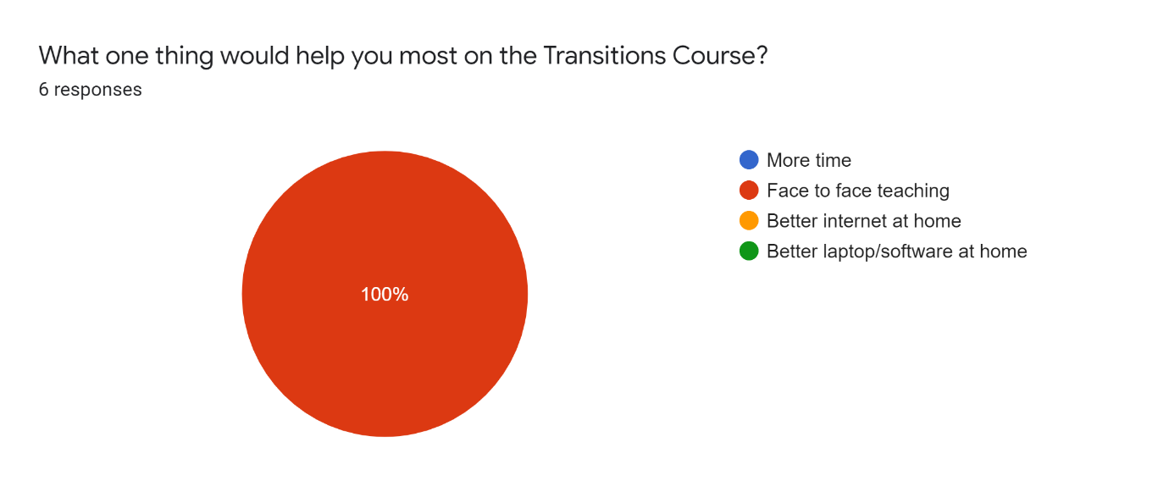

APPENDIX D

Interview Questions

- What was school like for you?

- What is it like having Asperger’s syndrome?

- Why did you apply to the Transitions Course?

- How do you feel about your future?

- What do you think about online learning?

APPENDIX E

Example of transcript

Interviewer (I):
Okay, so can I ask what age you are?

Respondent (R):
I am eighteen

I:
And are you a student on the Transitions course?

R:
Yes, I am.

I:
Have you got a diagnosis of Asperger’s syndrome?

R:
I do.

I:
So, I’ll start with the first question, what… can you tell me what school like was for you?

R:
School was okay. I had a few friends, and I enjoyed most of the classes.

I:
Which classes did you enjoy most?

R:
I enjoyed English and I also enjoyed PE sometimes.

I:
Are… was there any questions that you didn't enjoy so much?

R:
I didn't enjoy Art in the first two years, and then Maths.

I:
Okay. And did you have any, em, difficulties at school?

R:
I didn't have any difficulties.

I:
How did you get on with your teachers?

R:
I got on with most of them okay.

I:
Em, so that’s the first question done. The second question is what is it like having Asperger’s syndrome?

R:
Eh, it’s been okay having it, so it has.

I:
When did you get your diagnosis? How old were you?

R:
I got it when I was six.

I:
Six. Em, does it make you feel any different from anybody else your age, or…?

R:
No, I feel fine with it, it doesn't feel different or like I’m special or anything, I just feel normal with it.

I:
Okay. How does it, em… I don't know, what do you think of the effects of having Asperger’s syndrome? Does it make you, em… is it harder to get… do you think it’s harder to get organised stuff, or how are you with getting on with other people?

R:
I <INAUDIBLE 2.26> people, I rarely start a conversation with new people. I normally wait for new people to talk to me first. But for that, it’s been okay.

I:
Okay. And why did you apply to do the Transitions course?

R:
I applied for it because I thought it would help me prepare for college.

I:
Right, and what do you hope… what are you hoping to get from the Transitions course?

R:
I’m hoping to learn more and get more confidence.

I:
Confidence with going to college, or confidence doing the work, or…?

R:
Eh, confidence going to college.

I:
Okay. That’s number three, number four, how do you feel, em, about your future? How do you feel about getting on to other college courses?

R:
Eh, I feel like I would be quite nervous about it, but I think after the Transitions course, I should be okay.

I:
Okay, and how are you feeling at the moment about, em, getting through the pandemic?

R:
Eh, it’s been okay again for that. I miss my family and my friends, but it’s not that bad for the pandemic.

I:
And you still think you’d be able to get out the other side?

R:
Yeah.

I:
And the last question, what do you really think about online learning?

R:
Eh, I think it’s been okay. It’s good. Idea for the pandemic is good.

I:
What do you… what would you say you like most about online learning?

R:
Eh, not sure, really.

I:
Okay. Is there anything that you dislike about online learning?

R:
Nothing I can think of about… nothing I can think of.

I:
Okay. So, is there anything else that you want to add on that you feel you haven’t said in this interview that you want to say now, about having Asperger’s or being at college?

R:
Nope, nothing I can think of.

I:
Okay, thank you, I’m just going to press the stop record.

[END OF RECORDING]

